**Minor Project**

**Creating Resource Group :-**

* **Resource groups**: A resource group is a logical container into which **Azure resources** like web apps, databases, and storage accounts are deployed and managed.
* **Resources**: Resources are instances of services that you create,like virtual machine,storage,or SQL databases.
* Creating a resource group is the first most important thing to do before starting deploying anytime in azure.

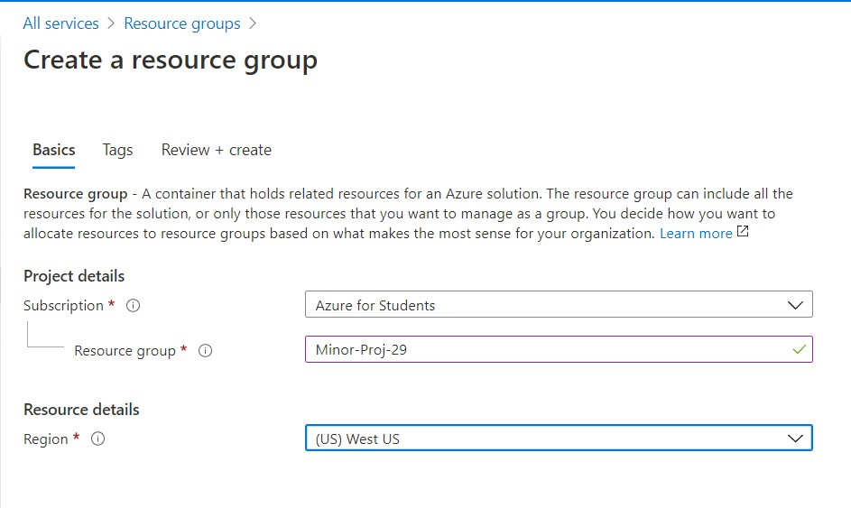

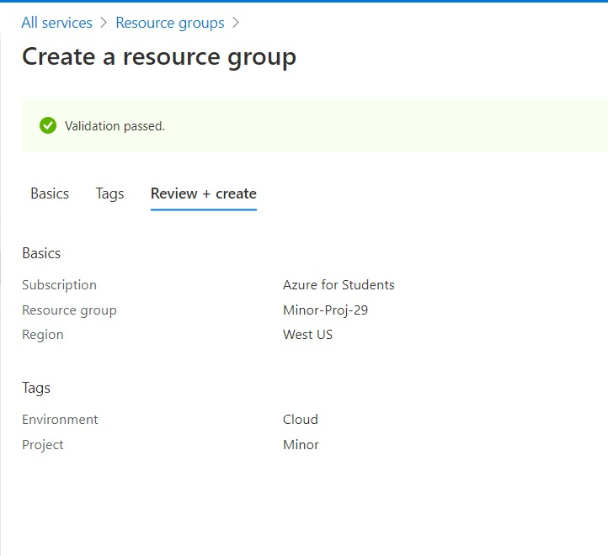

**Steps:**

All services Resource Group Add Basics Tags Review+create

* Basics - Give resource group name.

Create

Choose a particular region.

Next.

* Tags - Make an admin environment.

Make a project environment.

Next.

Create.

**Creating Virtual Network :-**

* **Azure Virtual Network** (**VNet**) is the fundamental building block for your private **network in Azure.**
* A **virtual network** is a **network** where all devices, servers, **virtual** machines, and data centers that are connected are done so through software and wireless technology.
* Results in secure communication among each other, the internet, and on-premises **networks**.

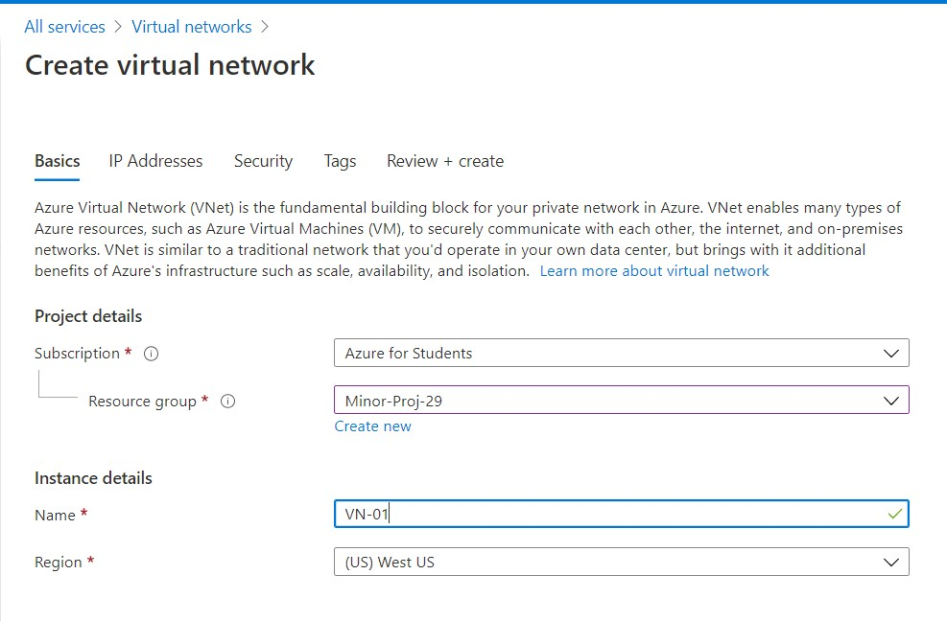

**SUBNET:-**

* **A Subnet** is a range of IP addresses in the VNet.
* It enables you to segment the virtual network into one or more sub-networks and allocate a portion of the virtual network’s address space to each subnet.
* Each **NIC** in a **VM** is connected one subnet in one **VNet.**
* **NICs** connected to **subnets(**same or different**)** within a **VNet** can communicate with each other without any extra configuration.

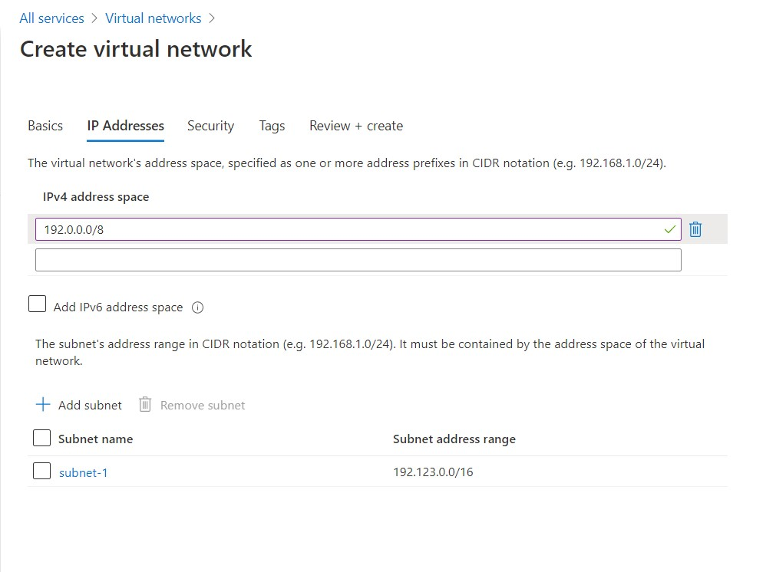

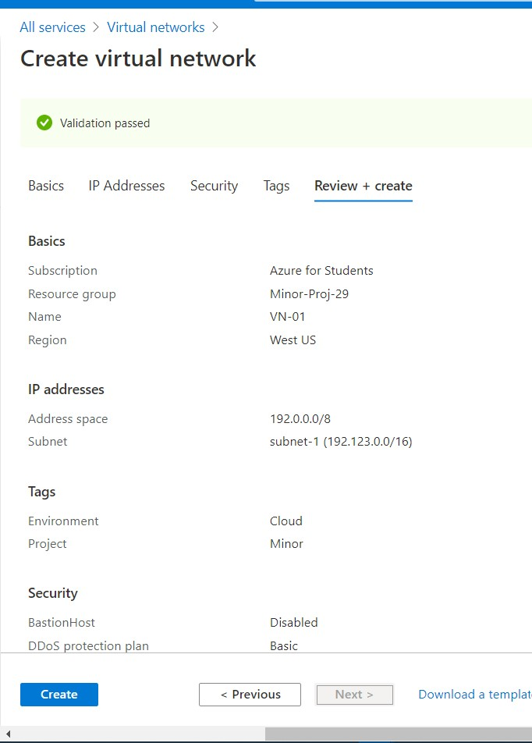

**Steps:**

All services Virtual Network Basics IP Addresses Security

* Basics - Give virtual network name.

Choose the same region of resource group.

Tags

Next.

* IP Addresses - Create a 8bit IPv4 address.

Create a subnet of 16 or 24 bit.

Okay.

Review+Create

Next.

* Security - Next
* Tags - Make an admin environment.

Make a project environment.

Next.

Create.

* Like this deploy **VN-02.**

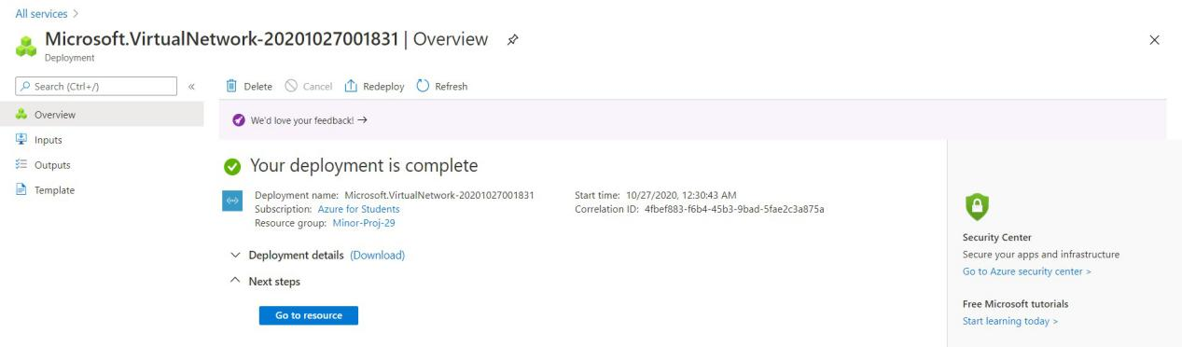

**Creating Virtual Machine:-**

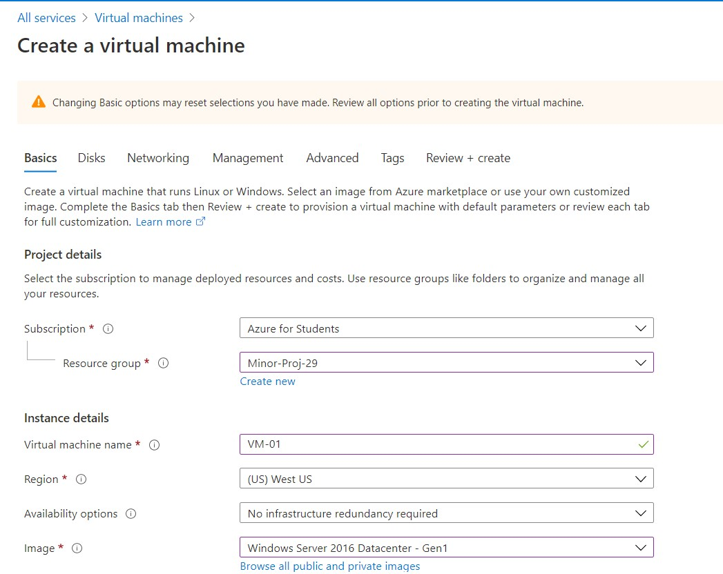

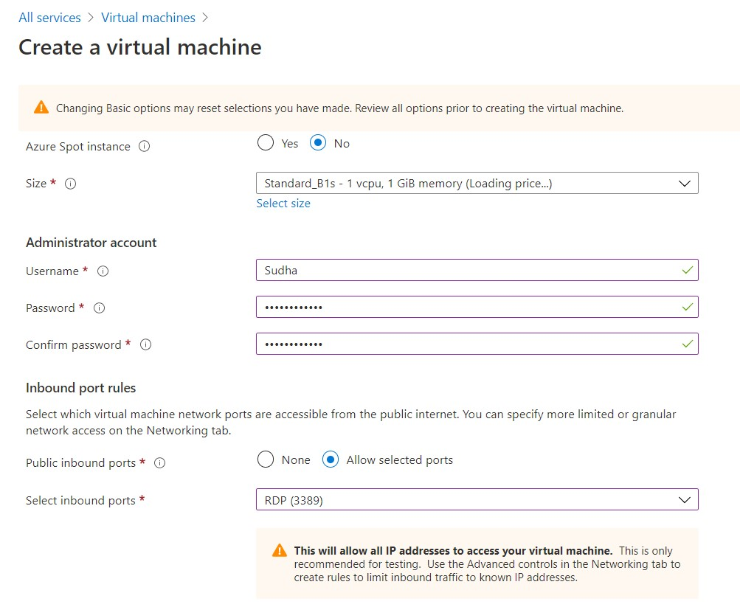

**Virtual Machine:-**

* A **virtual machine** (VM) is a virtual environment that functions as a virtual computer system with its own CPU, memory, network interface, and storage, created on a physical hardware system (located off- or on-premises).

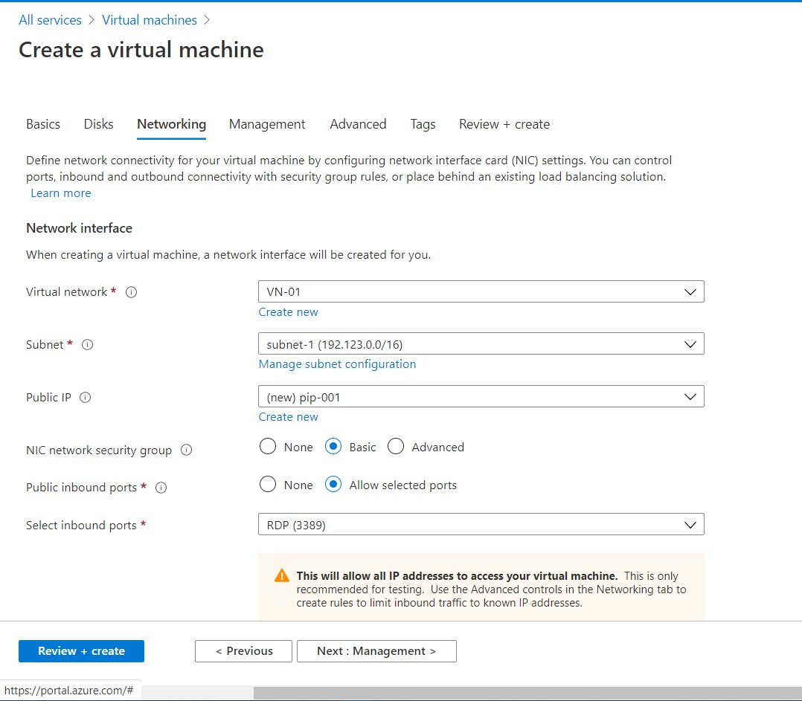

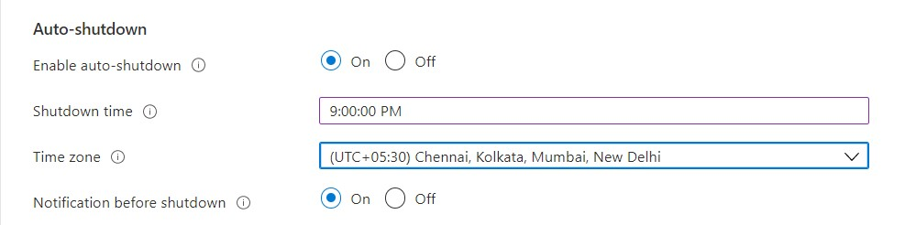

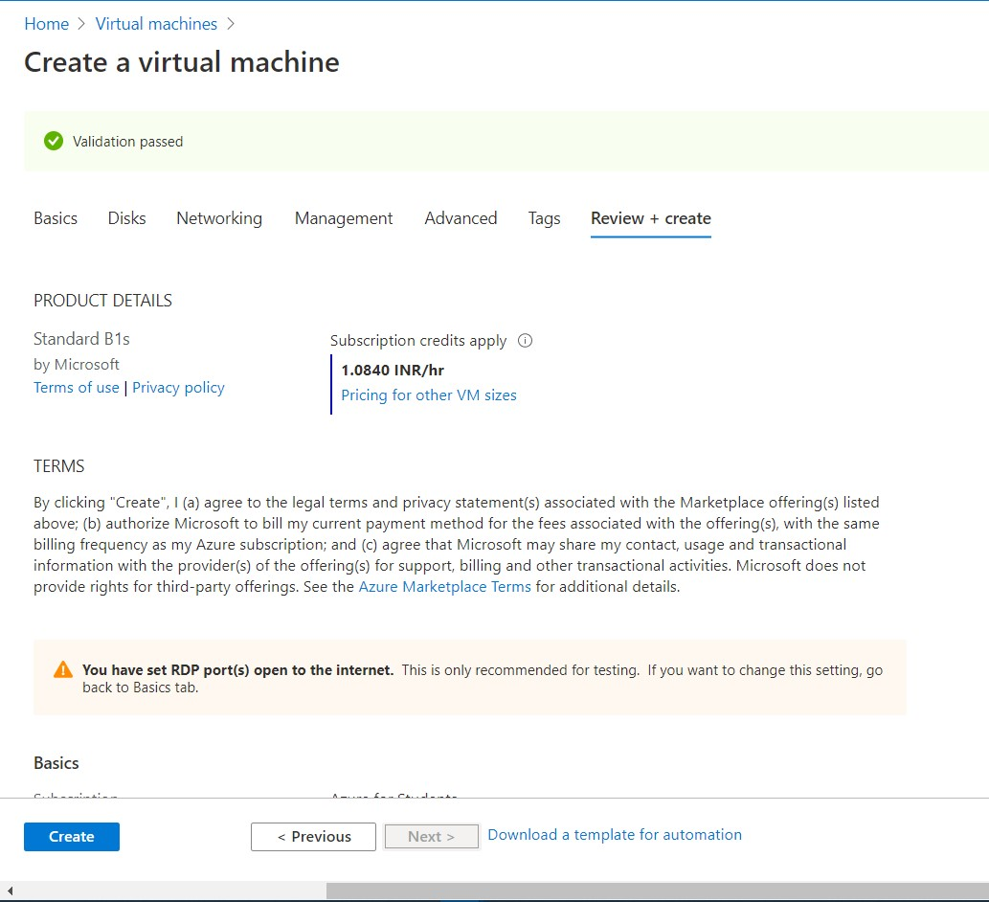



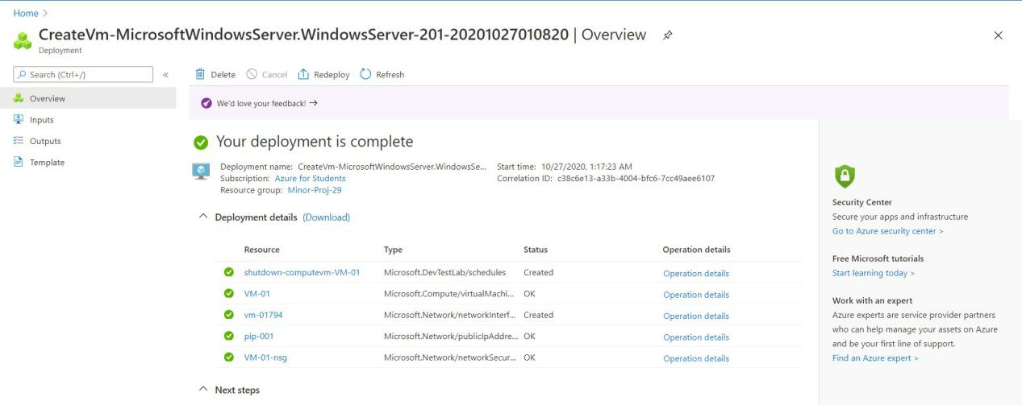

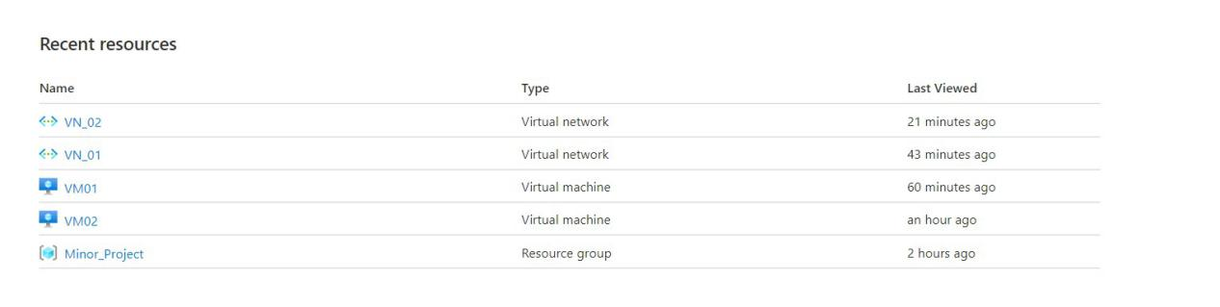

**Steps:-**

All services Virtual machines Basics Disks Networking

Review+Create

Tags

Advanced

Management

d

* Basics - Choose the resource group.

Give virtual machine name.

Choose the same region of VN.

Choose the image as Windows server 2016 data-center Gen-1.

Select size as for your requirement.(ex-Standard_B1s-1 vcpu,1

Gib memory)

Create user name and password for the virtual machine.

In inbound ports choose the port **RDP(3389)** as we have selected **Windows** as our virtual platform.

Next.

* Disks - Select Premium SSD.

Next

* Networking - Choose a VN where you want to deploy the VM.

**Create a public IP. OK.**

Next.

* Management - Enable Auto-shutdown.

Give the shutdown time to VM.

Select the time-Zone as per your preference.

Next.

* Advanced - Extension for security.(Optional)

VM Gen should be 1.(Azure VM disk doesn’t support Gen 2.)

Next.

* Tags - Make an admin environment.

Make a project environment.

Next.

Create.

* Review +Create
* Create Another VM as **VM-02.**

**Connecting to the Virtual Machine:-**

* In VM-01 go to Connect.
* Download RDP file
* Click Connect.
* Give the username and password.
* Click OK.
* It’ll show Remote Desktop Connection.Click Yes there.
* Now,VM-01 will open.

Downloading RDP File:-

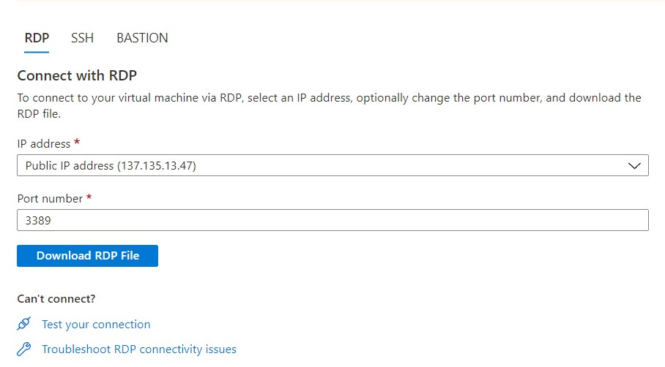

Remote Desktop Connection :-

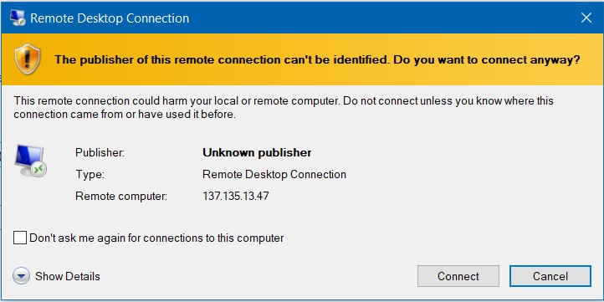

Credentials:-

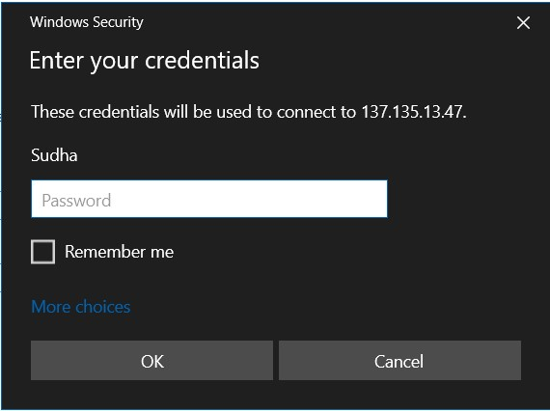

Remote Desktop Connection:-

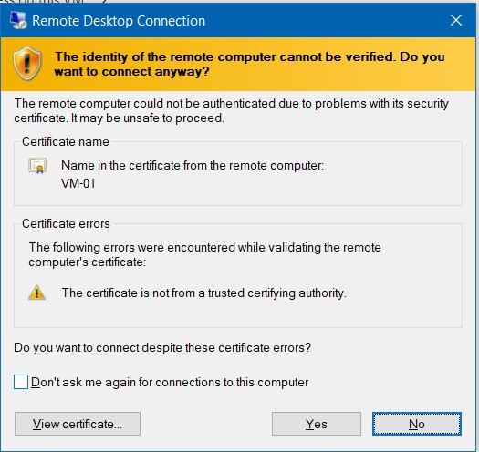

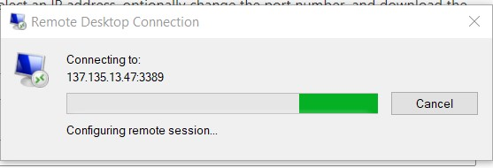

**Steps:-**

All services Virtual Machines VM-01 Connects RDP file

Download

Remote Desktop

Connection

VM

Credentials

Connect

OK

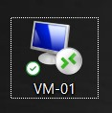

**VM-01**

**Peering:-**

* **Peering** is a method that allows **networks** to connect and exchange traffic directly without having to pay a third party to carry traffic across the **Internet**.

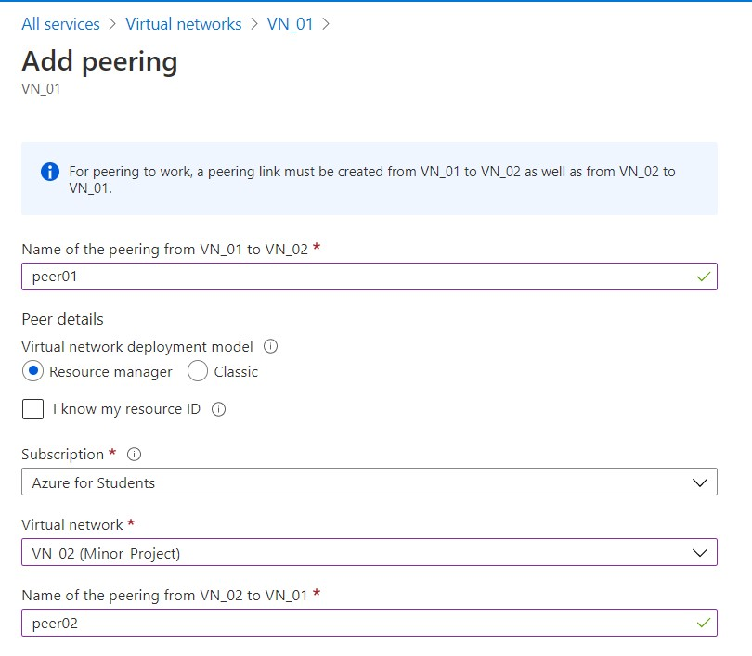

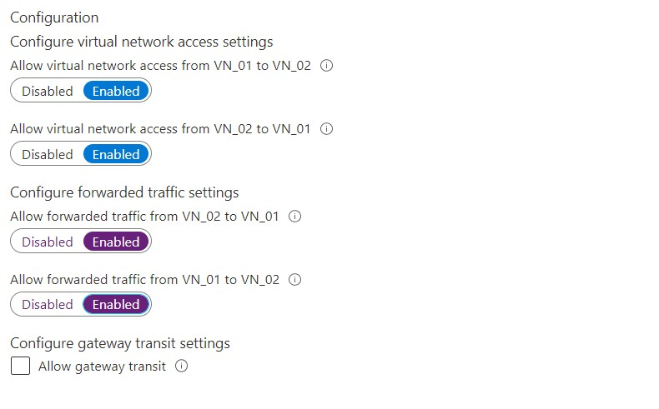

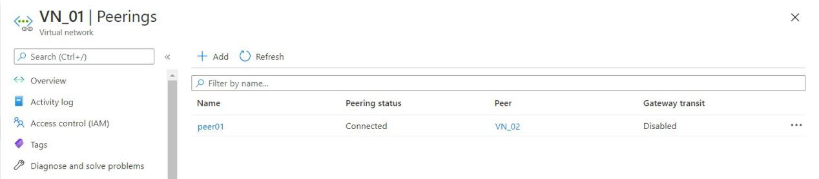

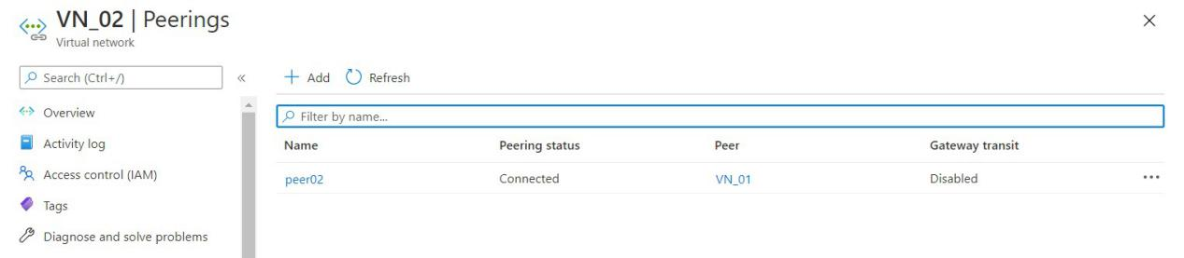

**Steps:-**

All services Virtual Network VN_01 Add peering

Save

**Add peering** **:-**

* Name the peering.
* Choose the VN with whom you want to peer.(here VN_02)
* Name the peering from VN_02 to VN_01.
* Enable the Traffics from VN_02 to VN_01 and VN_01 to VN_02.

By enabling the peering we will be able to exchange the information from one VN to other VN.

* Save it.

**Datadisk :-**

* Disks are block level storage volumes that are managed by Azure and used with azure virtual machines.
* Managed disks are like a physical disk in an on-premises server, but , virtualized.
* With managed disk all we have to do is specify the disk size,the disk type, and provision the disk.
* After provision Azure handles the rest.

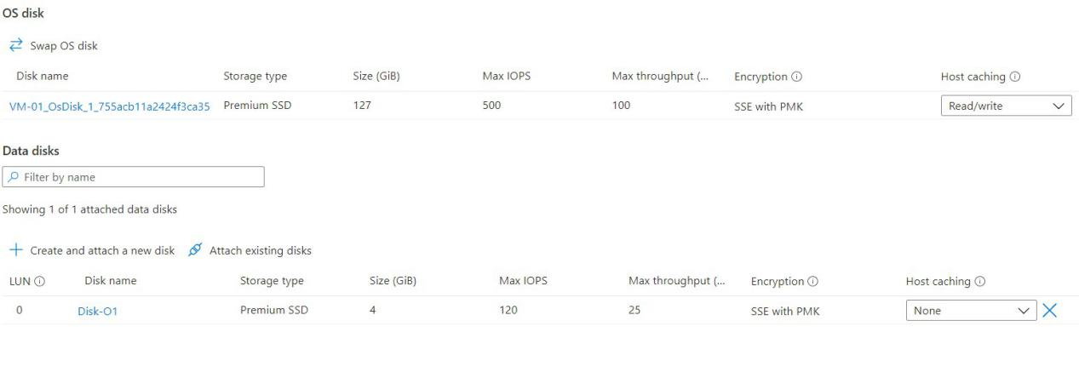

* The virtual machine contains an OS-disk.So, we need to create a new disk and attach it to the VM.
* We can detach the disk also. After detaching we’ll be able to find the disk again.

**Steps:-**

All services Virtual machines Disks Add Save

**Add:-**

* Create disk name.
* Save it.

**Login to VM and Initialize the Disk:-**

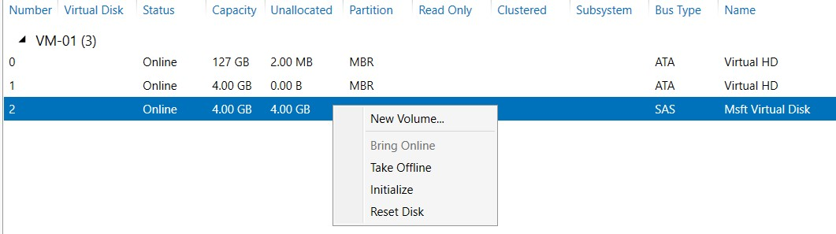

* Log in to VM.
* Go to server manager , and then file and storage , then go to disks.
* OR we can directly login to VM by pressing Windows + R , then write **mstsc** and click connect.
* In disks choose the disk you have created.
* Right-click on it.
* Then **initialize.**

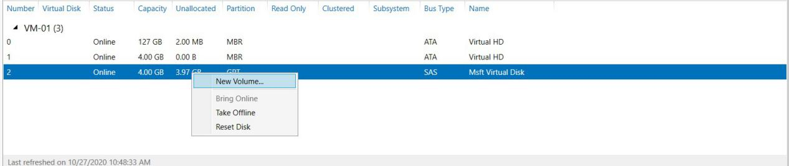

* Again right click on it.
* Choose new volume.
* Click on it.

**Steps:-**

Driver Letter or Folder

New Volume Before you began Server and Disk Size

File System Setting

Confirmation Results

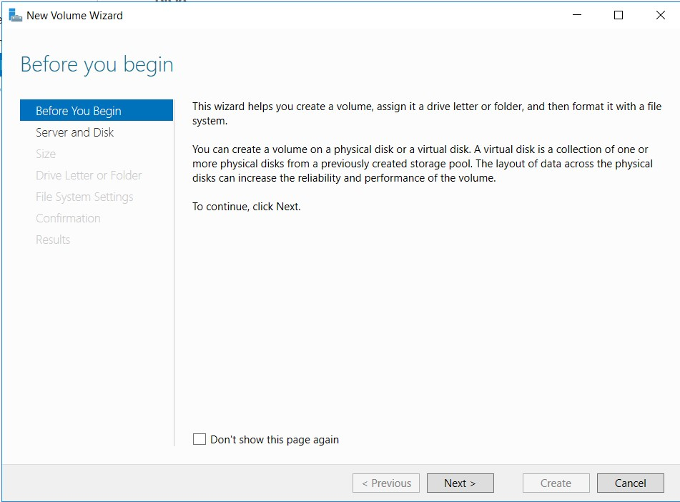

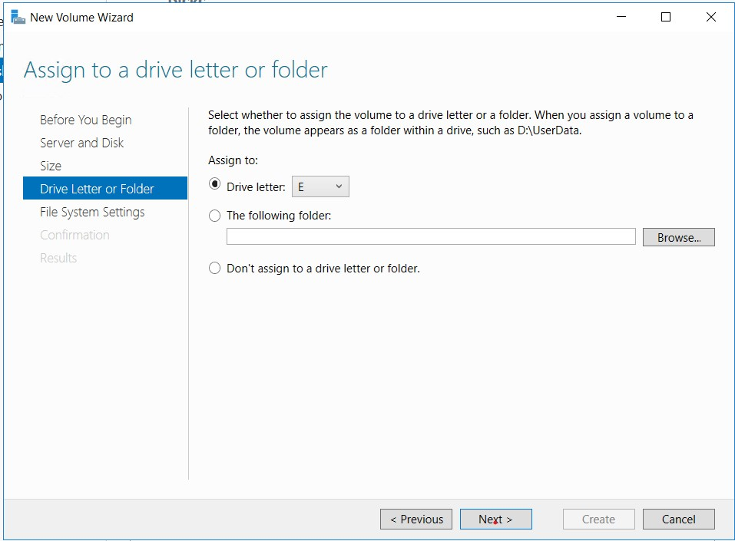

* In Drive letter select the letter . Click next.

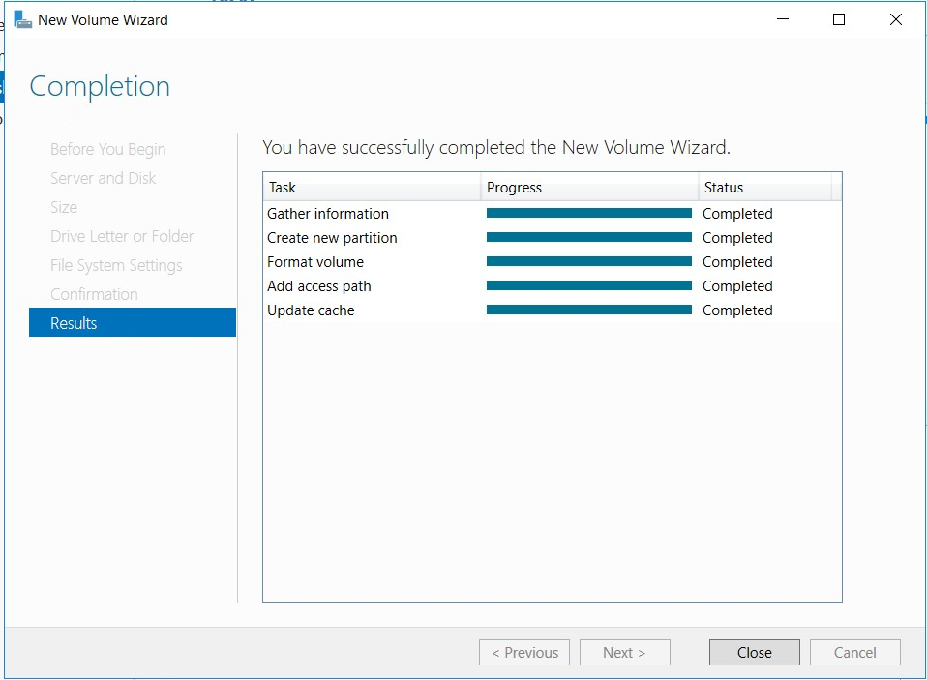

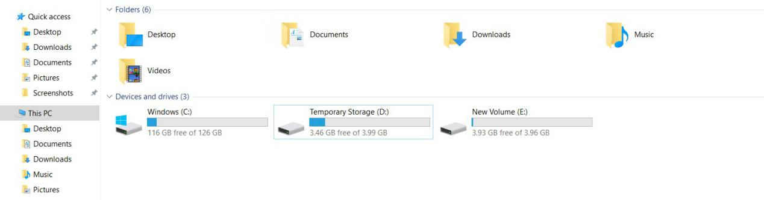

* Finally, the partition of the disk storage has been done.